|  |  |  |  |  |  |
| --- | --- | --- | --- | --- | --- |
| Date | 24-May-22 | | | Tester Name | Select Name |
| Environment | Select Environment | | | Login used |  |
| Operating System | Select OS | Version: | Update: | | |
| Software Used | Select Software | Version: | Update: | | |
| Select Software | Version: | Update: | | |
| Release version |  | | | | |
| Title | Enrolemnt | | | | |
| Test Type | Regression | | | | |
| Test Scenario | Re-enrolment via SIN - Same employer refunded MEPP status | | | | |
|  |  | | | | |
| Expected Results |  | | | | |
| Pass/Fail | Select | | | JIRA# | N/A |

Describe your steps with screenshots:

1. Find a member with refund status

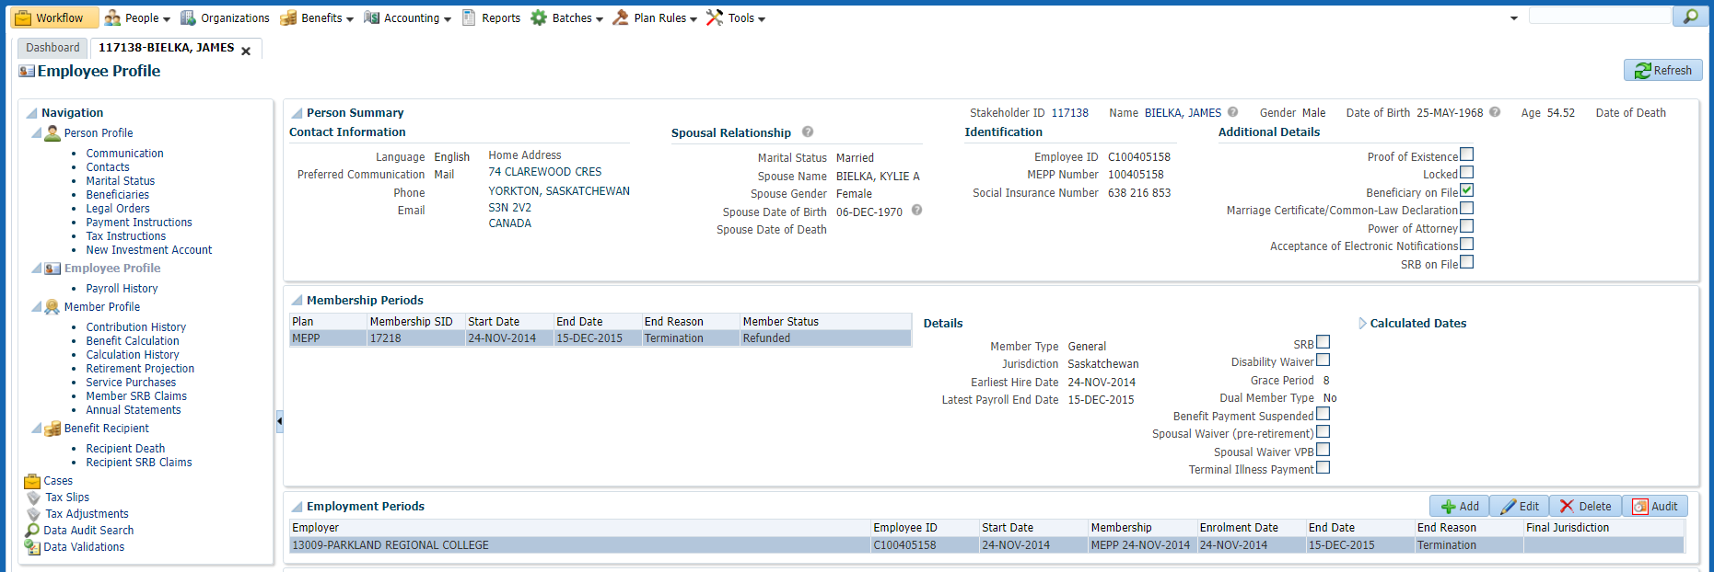

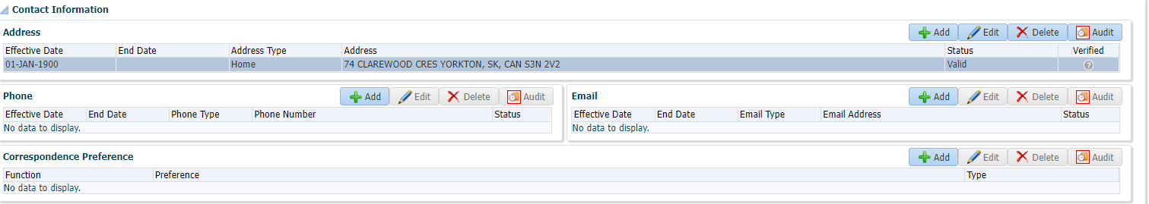

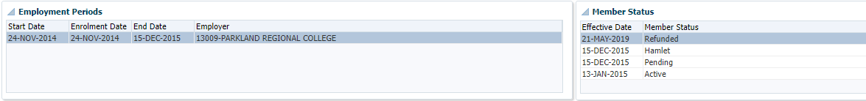

1. Login DCT to enroll the member (see testing M1.02)



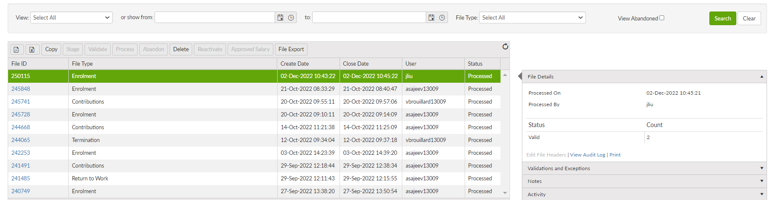

1. Data posting batch

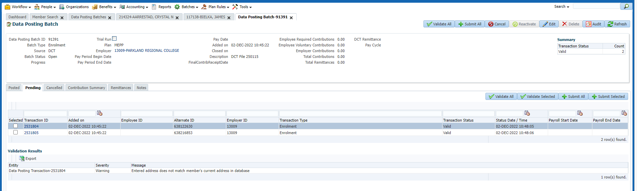

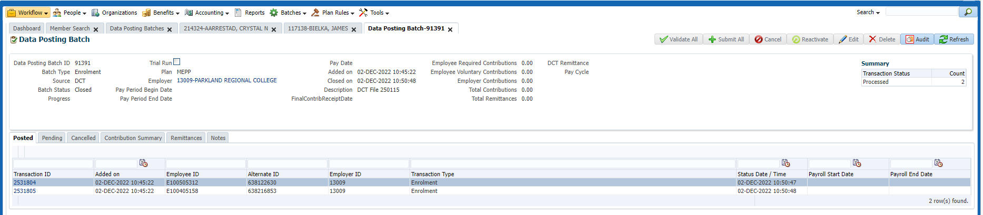

1. The member is active

